**Description of 03_hydro_data_Belley.csv**

Open the file 03_hydro_data_Belley.csv

This file refers to the output of an automatical computation and calculation metrics using discharge time series.

Then, these metrics will be modelled and analyzed to explain structure and dynamism of aquatic communities in large river floodplain.

The database was built by rows. Each row refers to a sampling date (year & season) in a site.

**First part of table => informations**

* **Sector**: reach of the river where are located station/sites (BE = Belley)
* **Station** : four first letters (id) of the name of each channel which includes some sites.
* **Site**: AM=>Upstream / CE : center / AV=> downstream part of the channel named « Station »
* **Year** => year of invertebrate sampling
* **Season** => season of invertebrate sampling
* **Date_sample** => precise date of invertebrate sampling
* **Qc** => discharge threshold before overflow by upstream (estimate by Station)
  + If Qc=0 => the channel is fully connected by upstream
  + If Qc>0 => discharge must be higher than Qc to connect by upstream
* **Qcs** => discharge threshold before inflow by downstream and surface connection (estimate by Site, sometimes by Station) => it means slow connection
  + If Qc=C => the channel is fully connected by downstream
  + If Qc >0 => discharge must be higher than Qc to connect by downstream the site
* **Lag** => lag time between gauging station (discharge) and elevation of water level in site.
* **Qref** => id of gauging station (discharge), specific for each channel.

From now, the **last letter** of each id metrics define the laps time during metrics have been calculated.

« **y** » means a period of 365 days before the sampling date

« **q** » means a period began the days when the discharge was the lowest (in winter) until the sampling date

« **2m** » means a period of 30 days before sampling date

« **m** » means a period of 30 days before sampling date

Example : Cf**y =>** the **y** means this metric has been calculated for a period of 365 days before the sampling date.

**Second part of table => overflow hydrological metrics (see 1 on Figure below)**

All these metrics have been calculated according the Qc threshold. If these metrics are empty (NA), it means that no overflow is possible in these site (or discharge data is not available).

* **Cmax** : maximum duration of the most important overflow above Qc (the most important flood in the channel)
* **Ce**: sum of duration of all overflow above Qc.
* **Cn**:number of overflow above Qc
* **Cf** : frequency of overflow above Qc
* **Cr**: recurrence of overflow above Qc (recurrence = 1/frequency)
* **Cq**: Water volume above the Qc threshold, it means the amplitude or the intensity of overflow (magnitude of the flood).

**Third part of table => inflow hydrological metrics (see 2 on Figure below) : slow connection**

All these metrics have been calculated according the Qcs threshold. If these metrics are empty (NA), it means that no inflow is possible in these site (or discharge data is not available).

As overflow, the same syntax has been used to define the inflow metrics.

* **Csmax** : maximum duration of the most important inflow above Qcs.
* **Cse**:….
* **Csn**:….
* **Csf**:….
* **Csr**:….
* **Csq**:….

These metrics have been calculated using discharge series.

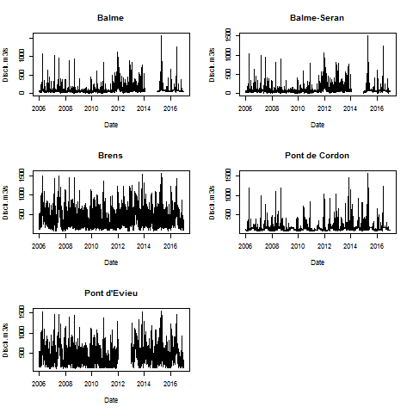

Discharge data are not available for 2014, consequently metrics can’t be computed for 2014 & 2015 sampling date.

C:\Users\marle\Desktop\Model\BEAR\AM\BEAR AM 2016 E.tiff

Example of an output of discharge computation: five metrics computed for four lap times.

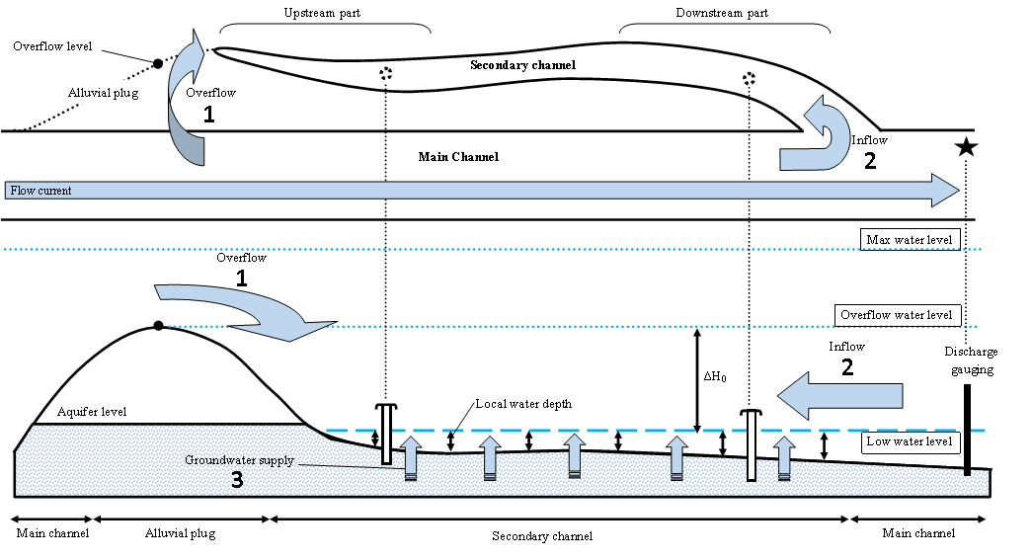

Figure 1. General principle of the method used for acquiring hydrological metrics. Above plan view and below longitudinal view. Blue arrows refer to a transfer or an input of a volume of water.